

**Informatics Institute of Technology**

Department of Computing   
BSc(Hons) in Software Engineering

**Module: 4COSC0011C Web Design & Development**

**Module Leader: Ms. Aloka Fernando  
  
Group Coursework Report**

Tutorial Group : SE Group D

CW Group No : Group 5

Student ID : 2017373

Student UoW ID : W1715758

Student First Name : Toran

Student Surname : Mayantha

Contents

1. Introduction 3

2. Technical Discussion 4

3. UI and application of UX principles 8

4. Janet 14

5. Conclusion 15

6. Appendices 15

# Introduction

|  |  |
| --- | --- |
| Toran Mayantha | Student 1 |
| Chamal Perera | Student 2 |
| Sandeepa Sewwandi | Student 3 |
| Dulitha Disal | Student 4 |

# Technical Discussion

* Presentation Page

This page includes the name and the title of the website. After 4 seconds this page will be directed to the home page.

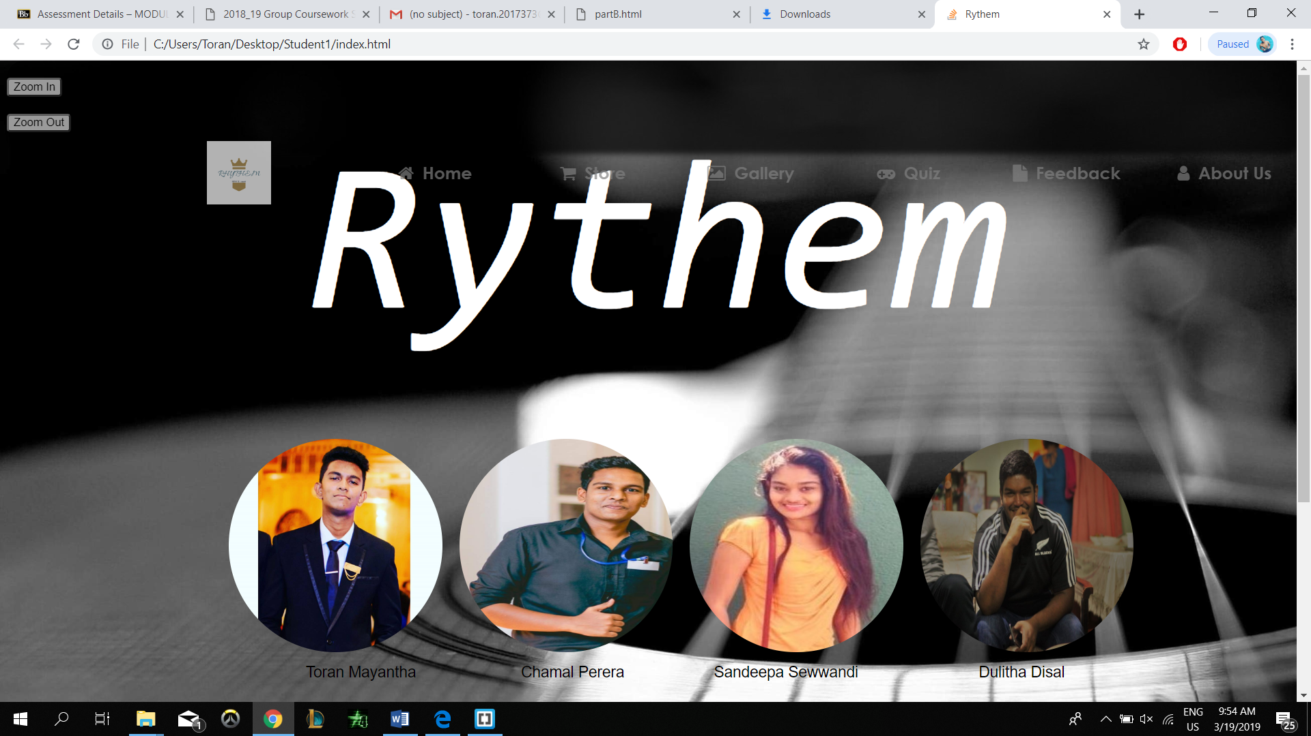

This page also includes button to zoom in and zoom out. User can change the font size of the webpage using this buttons.

When I started doing the presentation page I couldn’t find the way to set the timer for the webpage. To solve that issue I searched about “how to set the timer in a webpage” and I found the answer in w3schools.

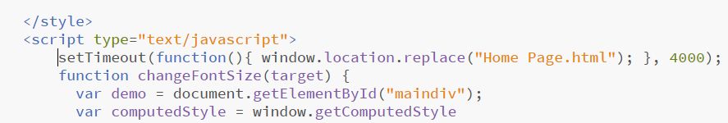

I used a div class and added the images of the creators to it and used a picture of a guitar as the background image.

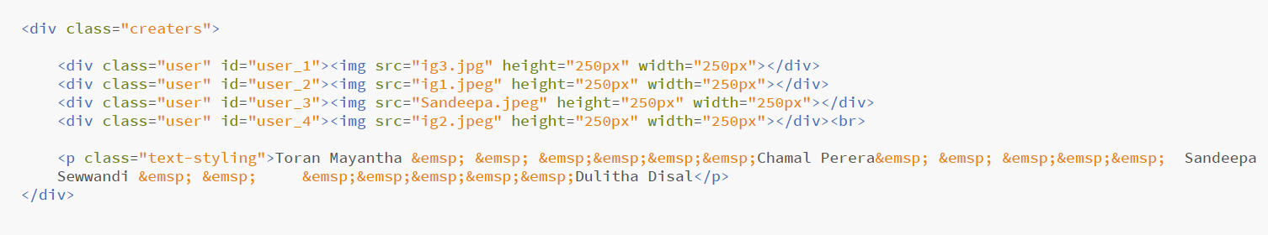

For the zoom in and zoom out buttons I searched in w3schools and I found the way to do it.

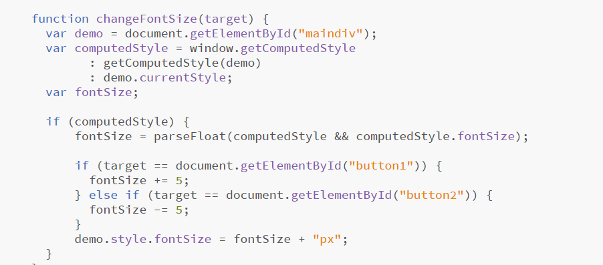

* Buy Products Page

This page is about the store of the website. User can go to the website and order guitars from the website. User can select guitars from 6 different types. User can also buy guitars with warranty or without warranty.

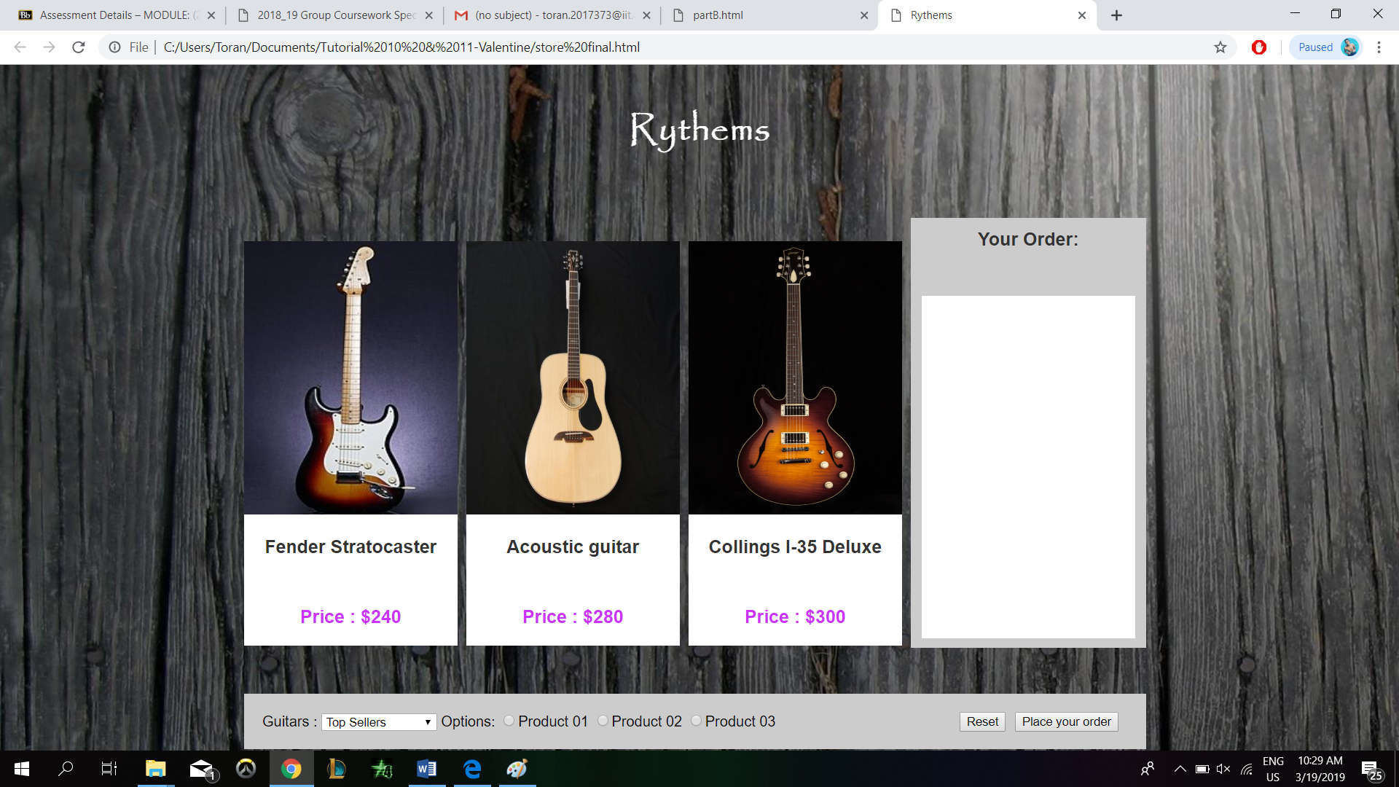

After placing your order the final bill is also displayed by the page.

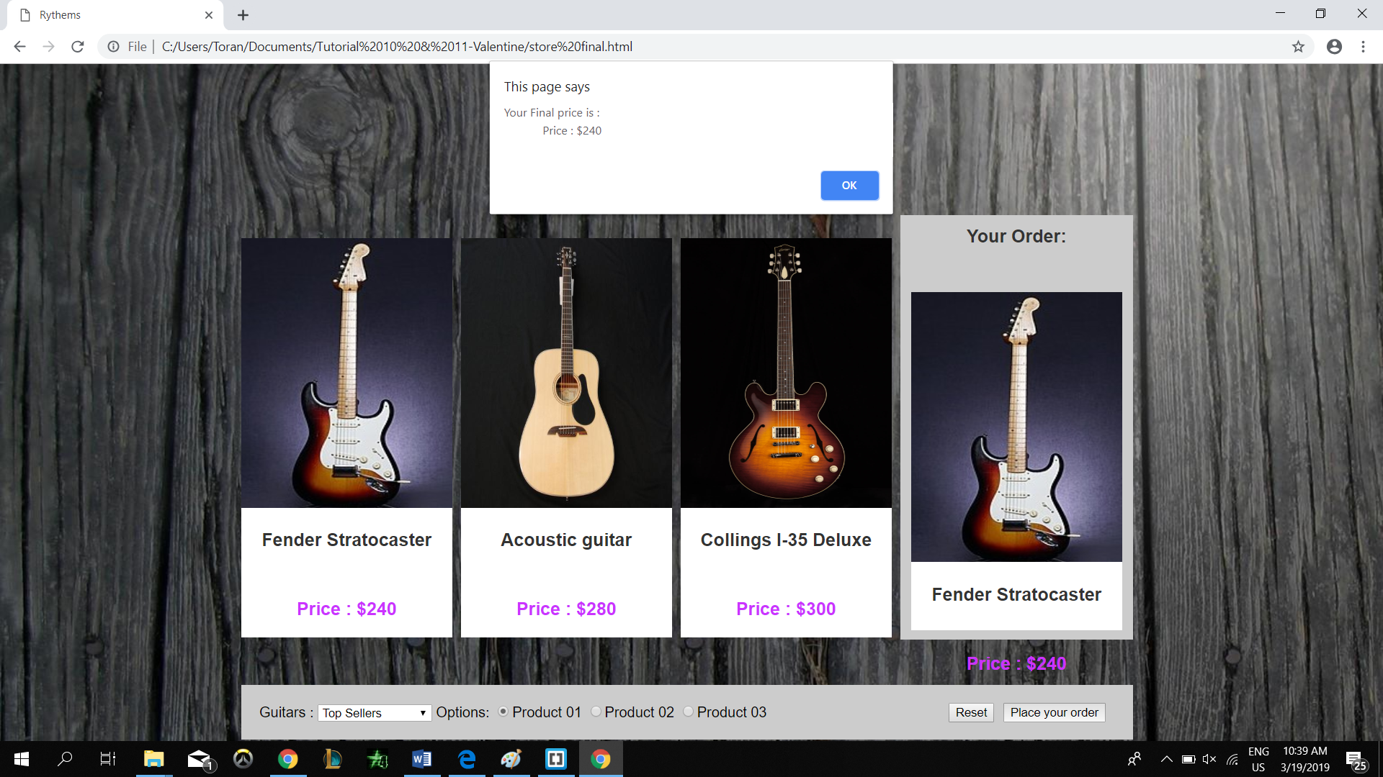

I also used radio buttons to navigate through the webpage.



For this webpage I tried using zoom in and zoom out buttons. But it didn’t worked for the store page. I couldn’t find a way to overcome that problem.

* CV

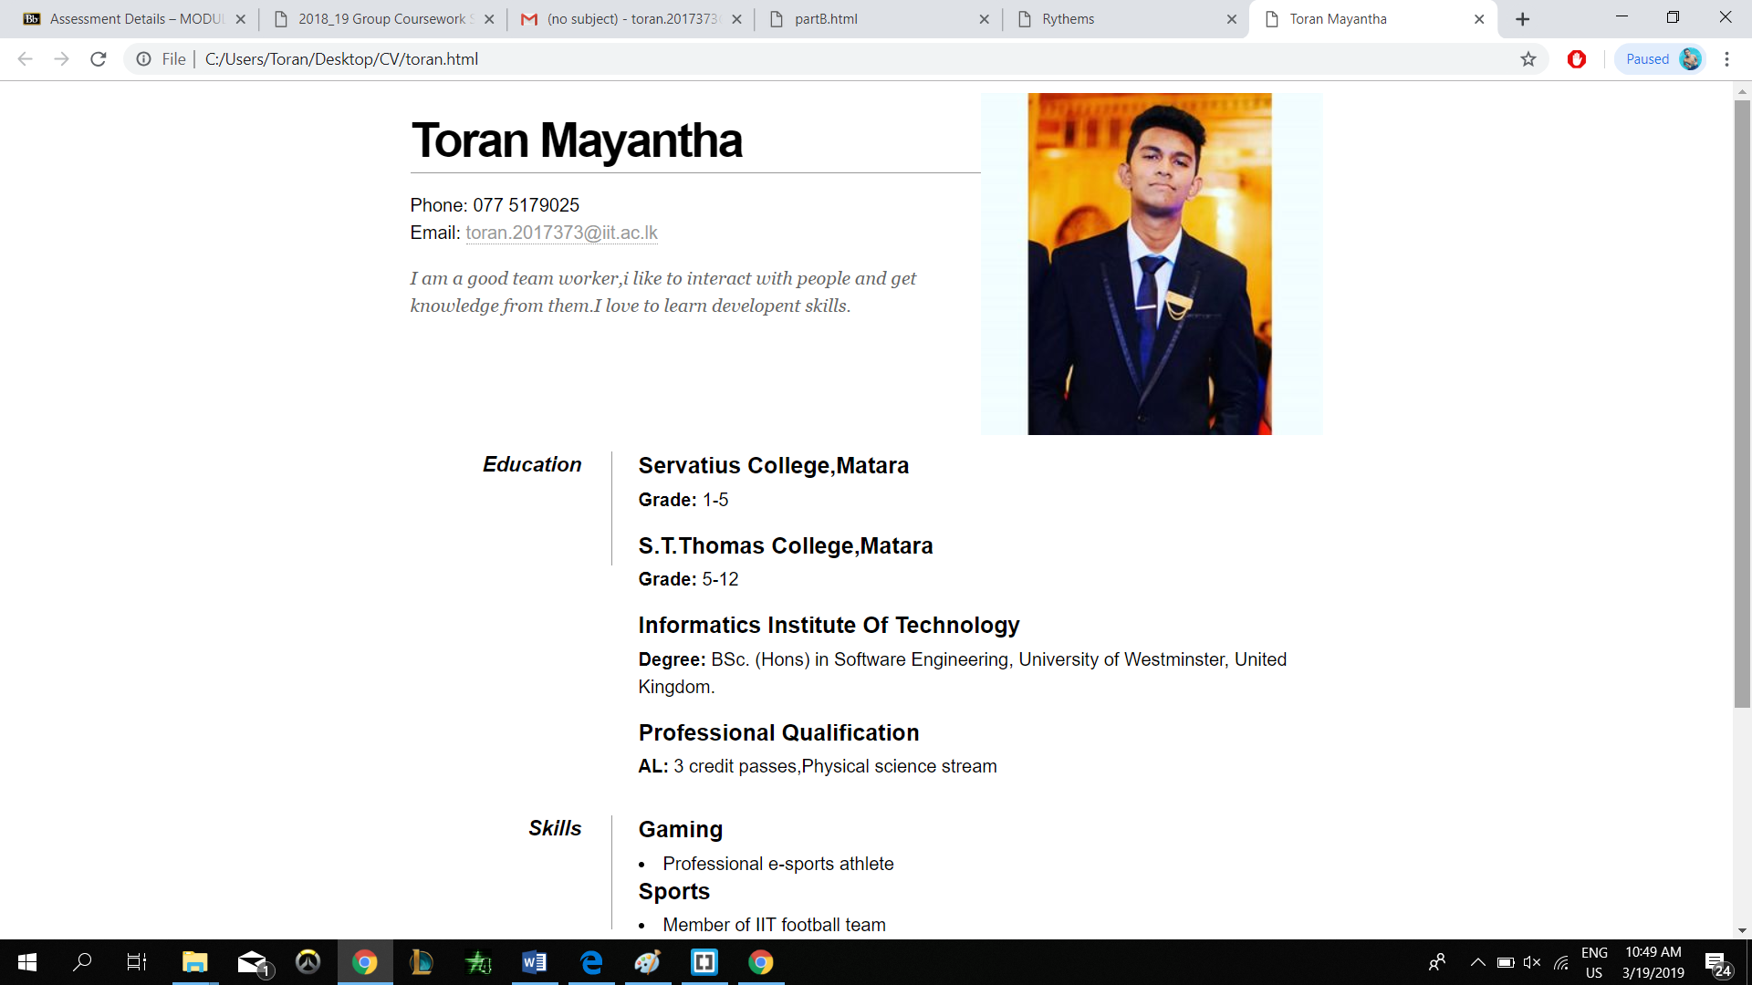

This page includes the personal details of myself.

# UI and application of UX principles

# 3.1 Information architecture

1. Design

Presentation Page

I managed to prepare the presentation page with pleasant good look. User can easily identify the content easily.

Store Page

I structured this page in a simple way that user can easily go and order items from the website.

1. Code to achieve good Information architecture

In my pages the information shared is less. So that the information architecture is simple. User can identify anything without messing.

* 1. Colour balance/composition/graphics/consistency

1. Design

Presentation Page

I used a background image of a guitar to presentation page because it is matching with our topic. And I balanced the header and footer that the website looks nicely.

Store Page

For this page also I used wooden type black image so that one goes with the theme very nicely.

b. Code to achieve good colour balance & ensure consistency

For the color balancing in store page I used white for the topic and the background is black. It looks pleasant to eye. I also used violet color to price tags in the store to match with other colors in the webpage.

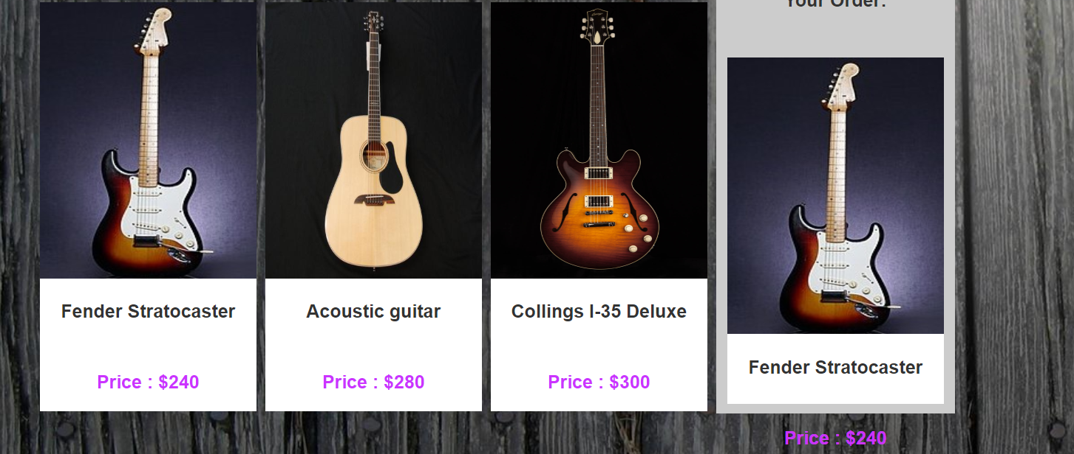

CSS In Store Page

body{

font-family: Arial;

background-image: url("149776.jpg");

}

h1{

font-family: Papyrus;

color: white;

text-align: center;

font-size: 40px;

margin: 40px 20px 80px 20px;

}

* 1. Typography / consistency

1. Design
2. Code to achieve good typography / consistency

For the both parts I have provided the screenshots of the css of webpages.

Presentation Page

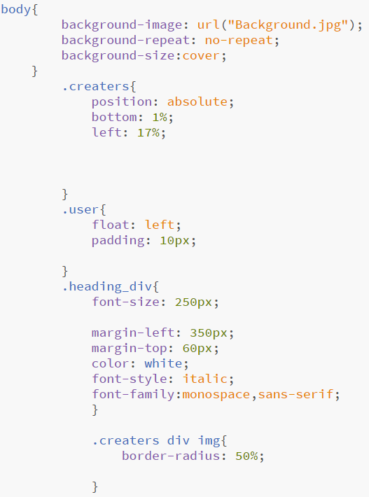

Store Page

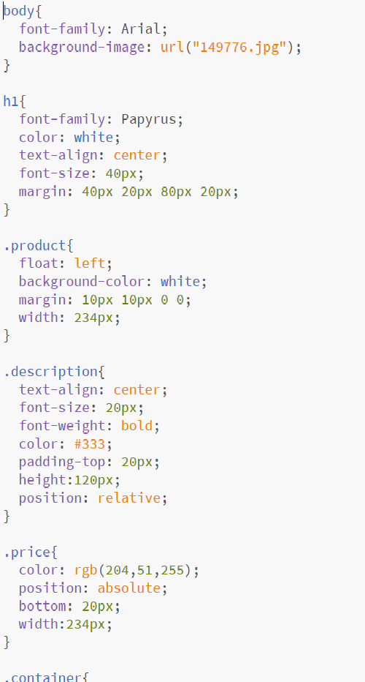

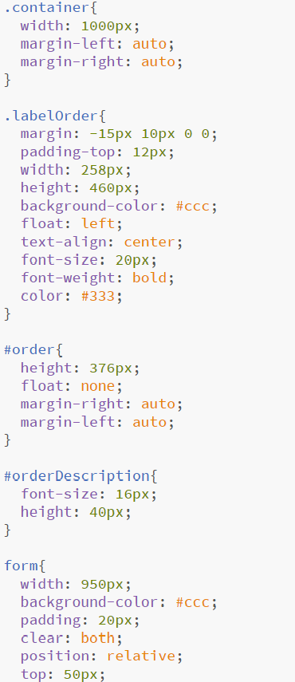

# Janet

**Compilation of the website with the use of Janet Regulations:**

* Disrupting the work of other users**:**

The site is not used to make any disruptive or offensive content. Everyone is free

to use the site without any disruption by the others.

* Corrupting or destroying other users data:

This website doesn’t corrupt or destroy other users data. Privacy is secured

although some of the information is taken as compulsory fields of data as feedback.

* Denying service to other users**:**

This site is designed to provide the fullest support and information as much as we can.

* Other misuse of Janet, such as the introduction of, viruses or other harmful software via Janet to resources on Janet, or on another user Organizations network:

We’ve made the site strong as much as we can not to receive and cyber attacks or threats.

* Deliberate unauthorized access to networked facilities or services:

Although I have linked social media like Twitter, Instagram, Facebook and Pinterest, the user have his/her own privacy because the user should have to log into their profiles in order to gain access to our site. It’s done under their own desire. No unauthorized access is used in the site.

# Conclusion

This report is about web designing coursework 1.This report covers all the areas of coursework. In introduction I have listed the members of the group and then I have explained the tasks that I have been carried out.

# Appendices

Appendix A : Code

Filename – Presentation Page

<!DOCTYPE html>

<html>

<head>

<link rel= "stylesheet" type="text/css" href="newstyle.css">

<title>Rythem</title>

<link rel="stylesheet" type="text/css" href="CSS\navigationbar.css">

<link rel="stylesheet" href="https://cdnjs.cloudflare.com/ajax/libs/font-awesome/4.7.0/css/font-awesome.min.css">

<!-- Here is the naviagtion bars icons link-->

<link href="https://fonts.googleapis.com/css?family=Lobster" rel="stylesheet">

<link href="https://fonts.googleapis.com/css?family=Amaranth|Changa|Economica" rel="stylesheet">

<meta charset="UTF-8">

<script type="text/javascript">

setTimeout(function(){ window.location.replace("Home Page.html"); }, 4000);

</script>

<script>

function changeFontSize(target) {

var demo = document.getElementById("maindiv");

var computedStyle = window.getComputedStyle

: getComputedStyle(demo)

: demo.currentStyle;

var fontSize;

if (computedStyle) {

fontSize = parseFloat(computedStyle && computedStyle.fontSize);

if (target == document.getElementById("button1")) {

fontSize += 5;

} else if (target == document.getElementById("button2")) {

fontSize -= 5;

}

demo.style.fontSize = fontSize + "px";

}

}

</script>

</head>

<body>

<div id="maindiv">

<div class="heading_div">Rythem</div>

<!-- Here starts the nav-->

<div class="nav">

<div id="button+">

<button id="button1" value="Increase" type="button" onclick="changeFontSize(this)">Zoom In</button>

</div>

<div id="button-">

<button id="button2" value="Decrease" type="button" onclick="changeFontSize(this)">Zoom Out</button>

</div>

<ul>

<!-- Here starts the logo and big1-->

<a class="logo" href="Home Page.html"><img src="Images/logo.png" width="75" height="75"></a>

<li><a class="big1" href="Home Page.html"><i class="fa fa-home"></i>Home</a></li>

<li><a class="big1" href="store.html"><i class="fa fa-shopping-cart"></i>Store</a></li>

<li><a class="big1" href="Gallery.html"><i class="fa fa-photo"></i>Gallery</a></li>

<li><a class="big1" href="newQuiz.html"><i class="fa fa-gamepad"></i>Quiz</a></li>

<li><a class="big1" href="Feedback.html"><i class="fa fa-file"></i>Feedback</a></li>

<li><a class="big1" href="about%20us.html"><i class="fa fa-user"></i>About Us</a></li>

</ul>

</div>

<div class="creaters">

<div class="user" id="user_1"><img src="ig3.jpg" height="250px" width="250px"></div>

<div class="user" id="user_2"><img src="ig1.jpeg" height="250px" width="250px"></div>

<div class="user" id="user_3"><img src="Sandeepa.jpeg" height="250px" width="250px"></div>

<div class="user" id="user_4"><img src="ig2.jpeg" height="250px" width="250px"></div><br>

<p class="text-styling">Toran Mayantha &emsp; &emsp; &emsp;&emsp;&emsp;&emsp;Chamal Perera&emsp; &emsp; &emsp;&emsp;&emsp; Sandeepa Sewwandi &emsp; &emsp; &emsp;&emsp;&emsp;&emsp;&emsp;Dulitha Disal</p>

</div>

<!-- Here starts the footer of website-->

<div class="footer" id="foot">

<div class="aboutsitetitle">Welcome to the world’s most popular music gear website.</div>

<div class="discription">

Guitar Center is the online marketplace for musicians to buy and learn about new, used, <br>vintage and handmade music guitars and gears.<br>

When Guitar Center launched in 2019, it was founded on the principle<br> that buying musical instruments should be easy and affordable.<br>

Since then we’ve become a thriving marketplace that connects millions<br> of people around the world to the gear and the inspiration needed to make music.

<p><a href="Site Map.html">Site Map</a></p>

</div>

<!-- Here starts the social media-->

<div class="socialmedia">

<a class="social">Social Media</a>

<a href="https://en-gb.facebook.com/login/"><img src="Images/fb.jpg" width="46" height="40"></a><!-- Here the facebook link and other things-->

<a href="https://www.instagram.com/accounts/login/"><img src="Images/insta.png" width="40" height="40"></a><!-- Here the facebook link and other things-->

<a href="https://accounts.snapchat.com/accounts/login?continue=https%3A%2F%2Faccounts.snapchat.com%2Faccounts%2Fwelcome"><img src="Images/snapchat.jpg" width="40" height="40"></a><!-- Here the facebook link and other things-->

<a href="https://twitter.com/login?lang=en"><img src="Images/twiter.jpg" width="40" height="40"></a><!-- Here the facebook link and other things-->

<div class="vl"></div>

<!--this one for make a vertical line-->

</div>

<div class="owner">Created By :-</div>

<a href="" class="ownerphoto"><img src="ig3.jpg" width="45" height="45"></a>

</div>

</div>

</body>

</html>

Filename – newstyle.css

body{

background-image: url("Background.jpg");

background-repeat: no-repeat;

background-size:cover;

}

.creaters{

position: absolute;

bottom: 1%;

left: 17%;

}

.user{

float: left;

padding: 10px;

}

.heading_div{

font-size: 250px;

margin-left: 350px;

margin-top: 60px;

color: white;

font-style: italic;

font-family:monospace,sans-serif;

}

.creaters div img{

border-radius: 50%;

}

.text-styling{

font-size:18px;

color: black;

font-family: Cassandra Personal Use, sans-serif;

margin-left: 100px;

}

.logo{margin-left: 20px;

}

#button1{

margin-top: 20px;

border-radius: 4px;

border-color: gray;

}

#button2{

margin-top: 20px;

border-radius: 4px;

border-color: gray;

}

Filename – Store

<!DOCTYPE html>

<html>

<head>

<title>Rythems</title>

<meta charset="utf-8" />

<link rel="stylesheet" type="text/css" href="mystyle.css" />

</head>

<body>

<div class="container">

<h1>Rythems</h1>

<div id = "function1" class = "product">

<img id = "image1" src = "pic01.jpg" alt = "White Bouquet" />

<div class="description">

Fender Stratocaster

<div class = "price" id = "whitePrice">

Price : $240

</div>

</div>

</div>

<div id = "function2" class = "product">

<img id = "image2" src = "pic06.jpg" alt = "Pink Bouquet" />

<div class = "description">

Acoustic guitar

<div class= "price" id = "pinkPrice">

Price : $280

</div>

</div>

</div>

<div id = "function3" class = "product">

<img id = "image3" src = "pic03.jpg" alt = "Red Bouquet" />

<div class = "description">

Collings I-35 Deluxe

<div class="price" id = "redPrice">

Price : $300

</div>

</div>

</div>

<div class="labelOrder">

Your Order:

<div id="orderDescription">

</div>

<div class="product" id="order">

</div>

</div>

<form name = "flowerForm">

Guitars :

<select id = "option" name = "Options">

<option value = "pleaseSelect0">

Top Sellers

</option>

<option value = "withChampagne">

With Warrenty

</option>

<option value = "extra">

Without Warrenty

</option>

</select>

Options:

<input type ="radio" name = "color" value = "white" id = "white"/>Product 01

<input type = "radio" name = "color" value = "pink" id = "pink" />Product 02

<input type = "radio" name = "color" value = "red" id = "red" />Product 03

<input type = "button" name = "order" value = "Place your order" onclick="displayFinalPrice()"/>

<input type = "reset" name = "reset" value = "Reset" />

</form>

</div>

<script>

var totalPrices = 0;

function getRadioValue (radio){

var radioArray = flowerForm.elements[radio];

var i;

for (i=0;i<radioArray.length;i++){

if (radioArray[i].checked){

return radioArray[i].value;

}

}

return "";

}

function getSelectedValue (selectList){

return selectList[selectList.selectedIndex].value;

}

function getSelectedText( selectList){

return selectList.options[ selectList.selectedIndex].text;

}

function CheckOptions (formRef){

var optionString = getSelectedValue(document.getElementById("option"));

if (optionString.indexOf("Champagne")>-1){

document.getElementById("image1").src = "pic04.jpg";

document.getElementById("image2").src = "pic05.jpg";

document.getElementById("image3").src = "pic06.jpg";

}else{

document.getElementById("image1").src = "pic01.jpg";

document.getElementById("image2").src = "pic02.jpg";

document.getElementById("image3").src = "pic03.jpg";

}

var chosenBouquet = getRadioValue('color');

displayBouquet(chosenBouquet);

}

function displayBouquet(chosenBouquet){

switch (chosenBouquet) {

case "white":

document.getElementById("order").innerHTML = document.getElementById("function1").innerHTML;

totalPrices = document.getElementById("whitePrice").innerHTML;

break;

case "pink":

document.getElementById("order").innerHTML = document.getElementById("function2").innerHTML;

totalPrices = document.getElementById("pinkPrice").innerHTML;

break;

case "red":

document.getElementById("order").innerHTML = document.getElementById("function3").innerHTML;

totalPrices = document.getElementById("redPrice").innerHTML;

break;

default:

}

}

function resetOrder (){

document.getElementById("image1").src = "pic01.jpg";

document.getElementById("image2").src = "pic02.jpg";

document.getElementById("image3").src = "pic03.jpg";

document.getElementById("order").innerHTML = "";

}

function displayFinalPrice(){

alert("Your Final price is : "+totalPrices)

}

document.forms[0].addEventListener("reset",resetOrder);

document.getElementById("white").addEventListener("click",function(){displayBouquet("white")});

document.getElementById("pink").addEventListener("click",function(){displayBouquet("pink")});

document.getElementById("red").addEventListener("click",function(){displayBouquet("red")});

document.getElementById("option").addEventListener("change",function(){CheckOptions(this.form)});

document.getElementById("image1").addEventListener("click",function(){

displayBouquet("white");

document.getElementById("white").checked=true;

})

document.getElementById("image2").addEventListener("click",function(){

displayBouquet("pink");

document.getElementById("pink").checked=true;

})

document.getElementById("image3").addEventListener("click",function(){

displayBouquet("red");

document.getElementById("red").checked=true;

})

</script>

</body>

</html>

Filename – mystyle.css

body{

font-family: Arial;

background-image: url("149776.jpg");

}

h1{

font-family: Papyrus;

color: white;

text-align: center;

font-size: 40px;

margin: 40px 20px 80px 20px;

}

.product{

float: left;

background-color: white;

margin: 10px 10px 0 0;

width: 234px;

}

.description{

text-align: center;

font-size: 20px;

font-weight: bold;

color: #333;

padding-top: 20px;

height:120px;

position: relative;

}

.price{

color: rgb(204,51,255);

position: absolute;

bottom: 20px;

width:234px;

}

.container{

width: 1000px;

margin-left: auto;

margin-right: auto;

}

.labelOrder{

margin: -15px 10px 0 0;

padding-top: 12px;

width: 258px;

height: 460px;

background-color: #ccc;

float: left;

text-align: center;

font-size: 20px;

font-weight: bold;

color: #333;

}

#order{

height: 376px;

float: none;

margin-right: auto;

margin-left: auto;

}

#orderDescription{

font-size: 16px;

height: 40px;

}

form{

width: 950px;

background-color: #ccc;

padding: 20px;

clear: both;

position: relative;

top: 50px;

}

input[type=button],input[type=reset]{

float: right;

margin-right: 10px;

}

#image1{

width: 234px;

height: 300px;

}

#image2{

width: 234px;

height: 300px;

}

#image3{

width: 234px;

height: 300px;

}

Filename – CV

<!DOCTYPE html PUBLIC "-//W3C//DTD XHTML 1.0 Strict//EN"

"http://www.w3.org/TR/xhtml1/DTD/xhtml1-strict.dtd">

<html xmlns="http://www.w3.org/1999/xhtml" xml:lang="en" lang="en">

<head>

<meta http-equiv="Content-Type" content="text/html; charset=utf-8"/>

<title>Toran Mayantha</title>

<style type="text/css">

* { margin: 0; padding: 0; }

body { font: 16px Helvetica, Sans-Serif; line-height: 24px; background: url(images/noise.jpg); }

.clear { clear: both; }

#page-wrap { width: 800px; margin: 40px auto 60px; }

#pic { float: right; margin: -30px 0 0 0; }

h1 { margin: 0 0 16px 0; padding: 0 0 16px 0; font-size: 42px; font-weight: bold; letter-spacing: -2px; border-bottom: 1px solid #999; }

h2 { font-size: 20px; margin: 0 0 6px 0; position: relative; }

h2 span { position: absolute; bottom: 0; right: 0; font-style: italic; font-family: Georgia, Serif; font-size: 16px; color: #999; font-weight: normal; }

p { margin: 0 0 16px 0; }

a { color: #999; text-decoration: none; border-bottom: 1px dotted #999; }

a:hover { border-bottom-style: solid; color: black; }

ul { margin: 0 0 32px 17px; }

#objective { width: 500px; float: left; }

#objective p { font-family: Georgia, Serif; font-style: italic; color: #666; }

dt { font-style: italic; font-weight: bold; font-size: 18px; text-align: right; padding: 0 26px 0 0; width: 150px; float: left; height: 100px; border-right: 1px solid #999; }

dd { width: 600px; float: right; }

dd.clear { float: none; margin: 0; height: 15px; }

</style>

</head>

<body>

<div id="page-wrap">

<img src="ig3.jpeg" alt="Photo of Toran" id="pic" />

<div id="contact-info" class="vcard">

<!-- Microformats! -->

<h1 class="fn">Toran Mayantha</h1>

<p>

Phone: <span class="tel">077 5179025</span><br />

Email: <a class="email" href="mailto:toran@styles.com">toran.2017373@iit.ac.lk</a>

</p>

</div>

<div id="objective">

<p>

I am a good team worker,i like to interact with people and get knowledge from them.I love to learn developent skills.

</p>

</div>

<div class="clear"></div>

<dl>

<dd class="clear"></dd>

<dt>Education</dt>

<dd>

<h2>Servatius College,Matara</h2>

<p><strong>Grade:</strong> 1-5<br />

</dd>

<dd>

<h2>S.T.Thomas College,Matara</h2>

<p><strong>Grade:</strong> 5-12<br />

</dd>

<dd>

<h2>Informatics Institute Of Technology</h2>

<p><strong>Degree:</strong> BSc. (Hons) in Software Engineering, University of Westminster,

United Kingdom.<br />

</dd>

<dd>

<h2>Professional Qualification</h2>

<p><strong>AL:</strong> 3 credit passes,Physical science stream<br />

</dd>

<dd class="clear"></dd>

<dt>Skills</dt>

<dd>

<h2>Gaming</h2>

<li>Professional e-sports athlete</li>

<h2>Sports</h2>

<li>Member of IIT football team</li>

<li>Former cricket player</li>

<h2>Clubs And Societies</h2>

<li> Member of the Rotaract Club Of IIT</li>

</dd>

<dd class="clear"></dd>

<dt>Hobbies</dt>

<dd><li>Watching Movies</li>

<li>Reading Books</li></dd>

<dd class="clear"></dd>

</dl>

<div class="clear"></div>

</div>

</body>

</html>

Appendix B : Screenshots

Filename – Presentation Page

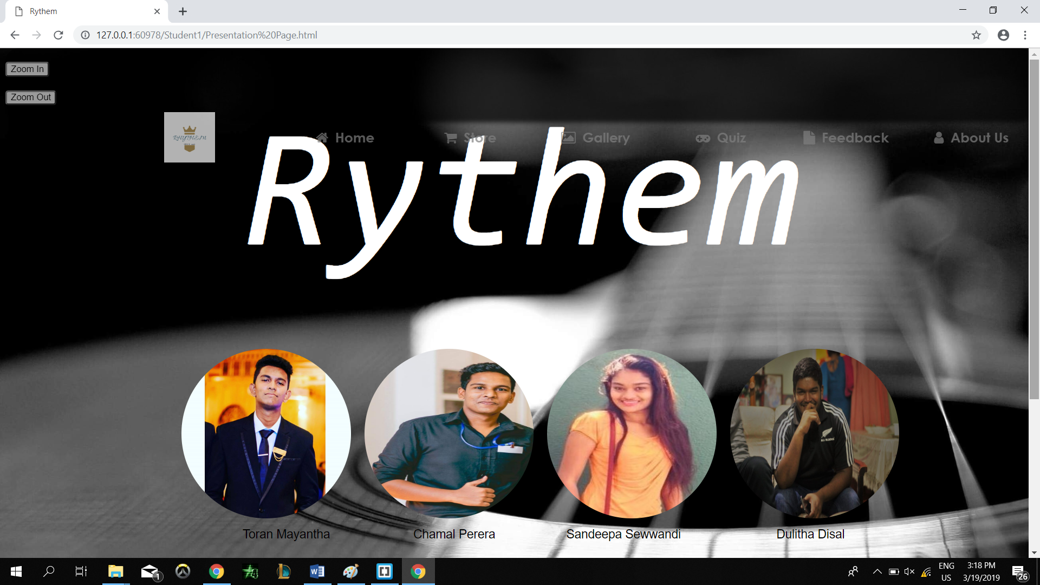

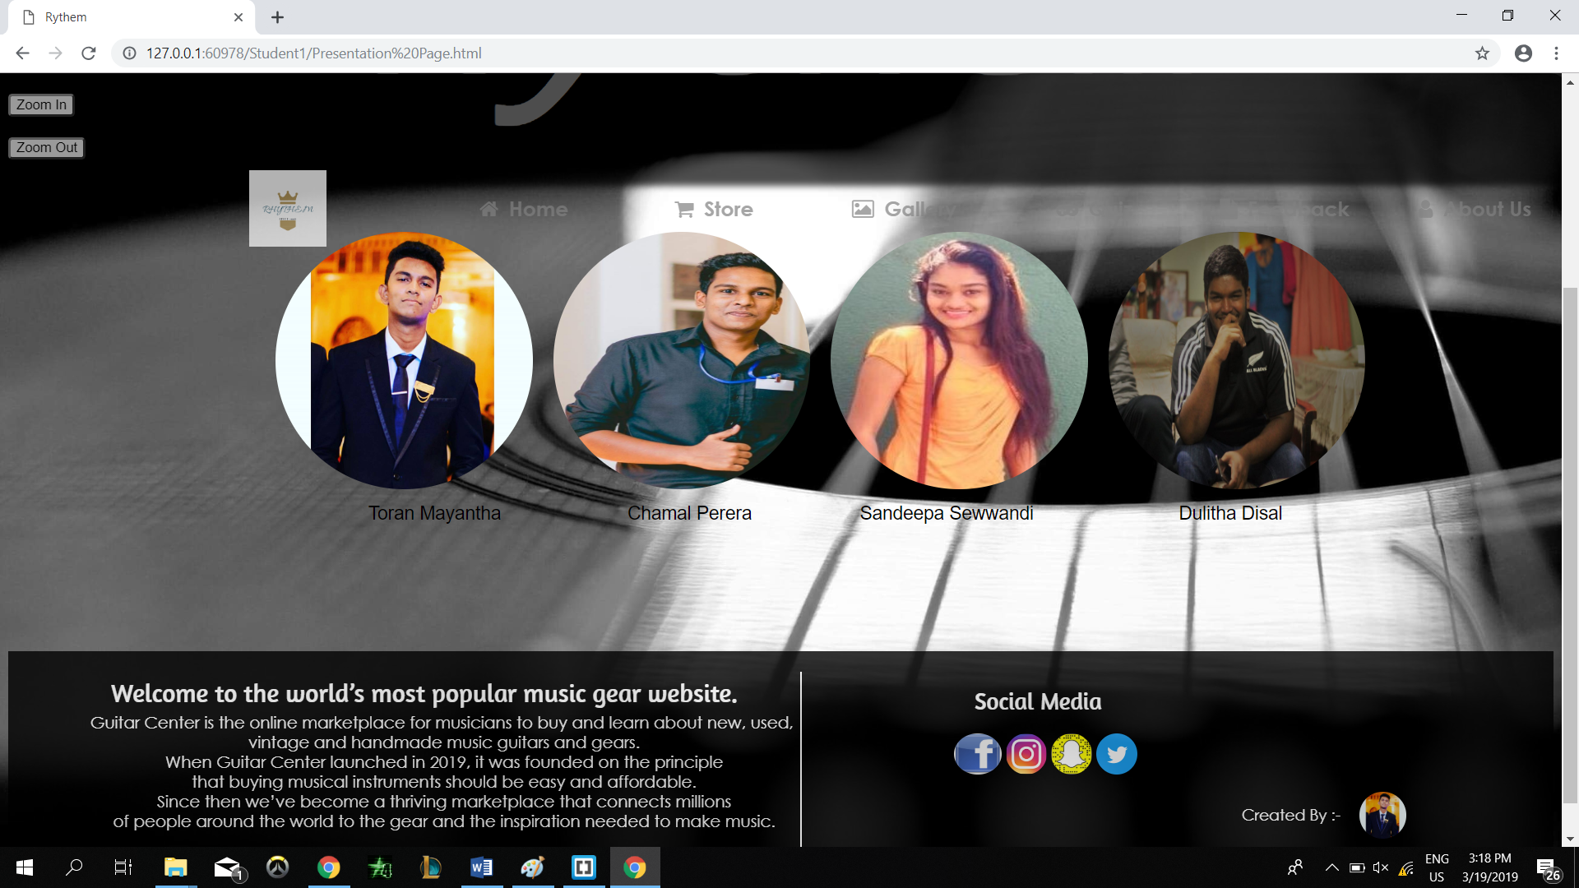

Filename – Store

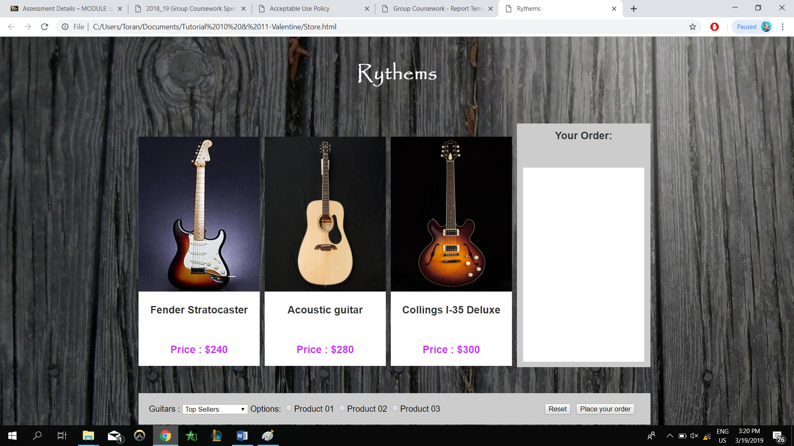

Filename – CV

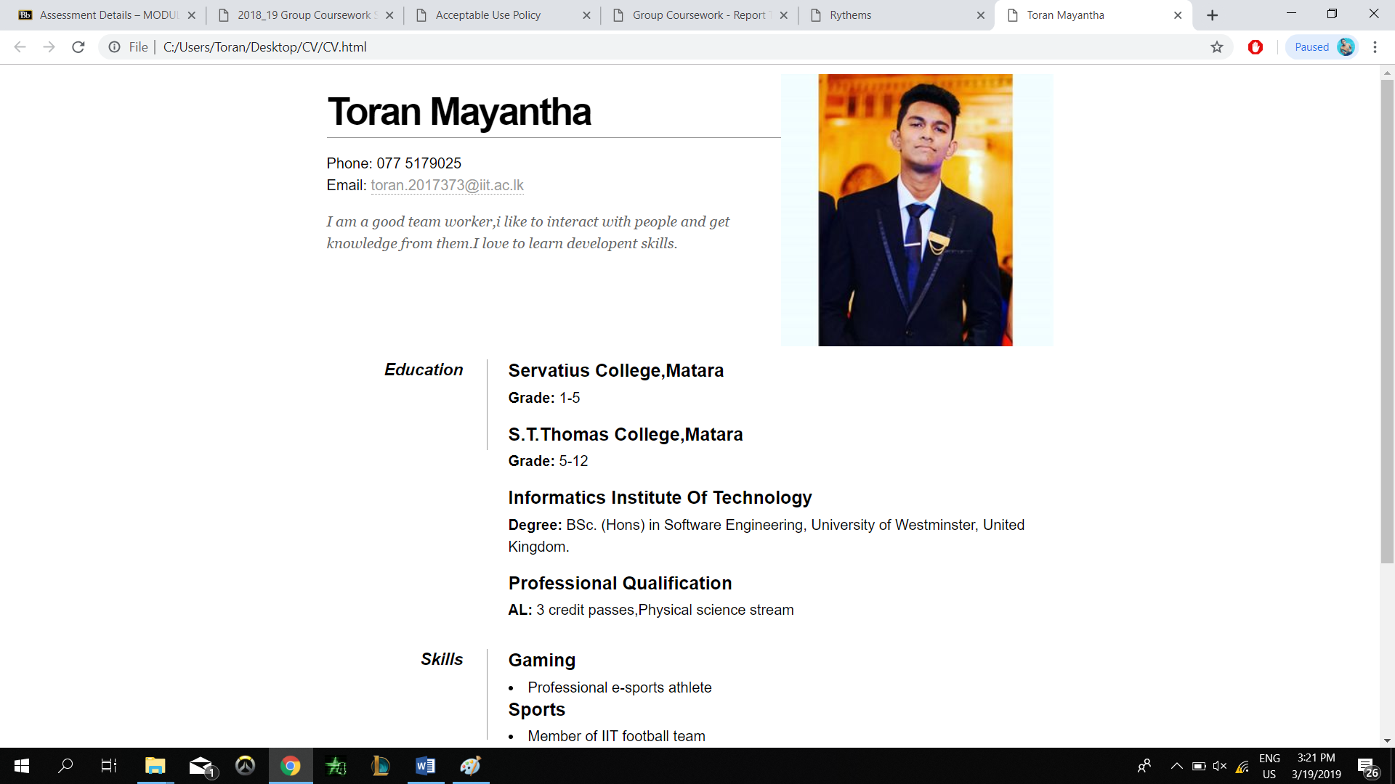

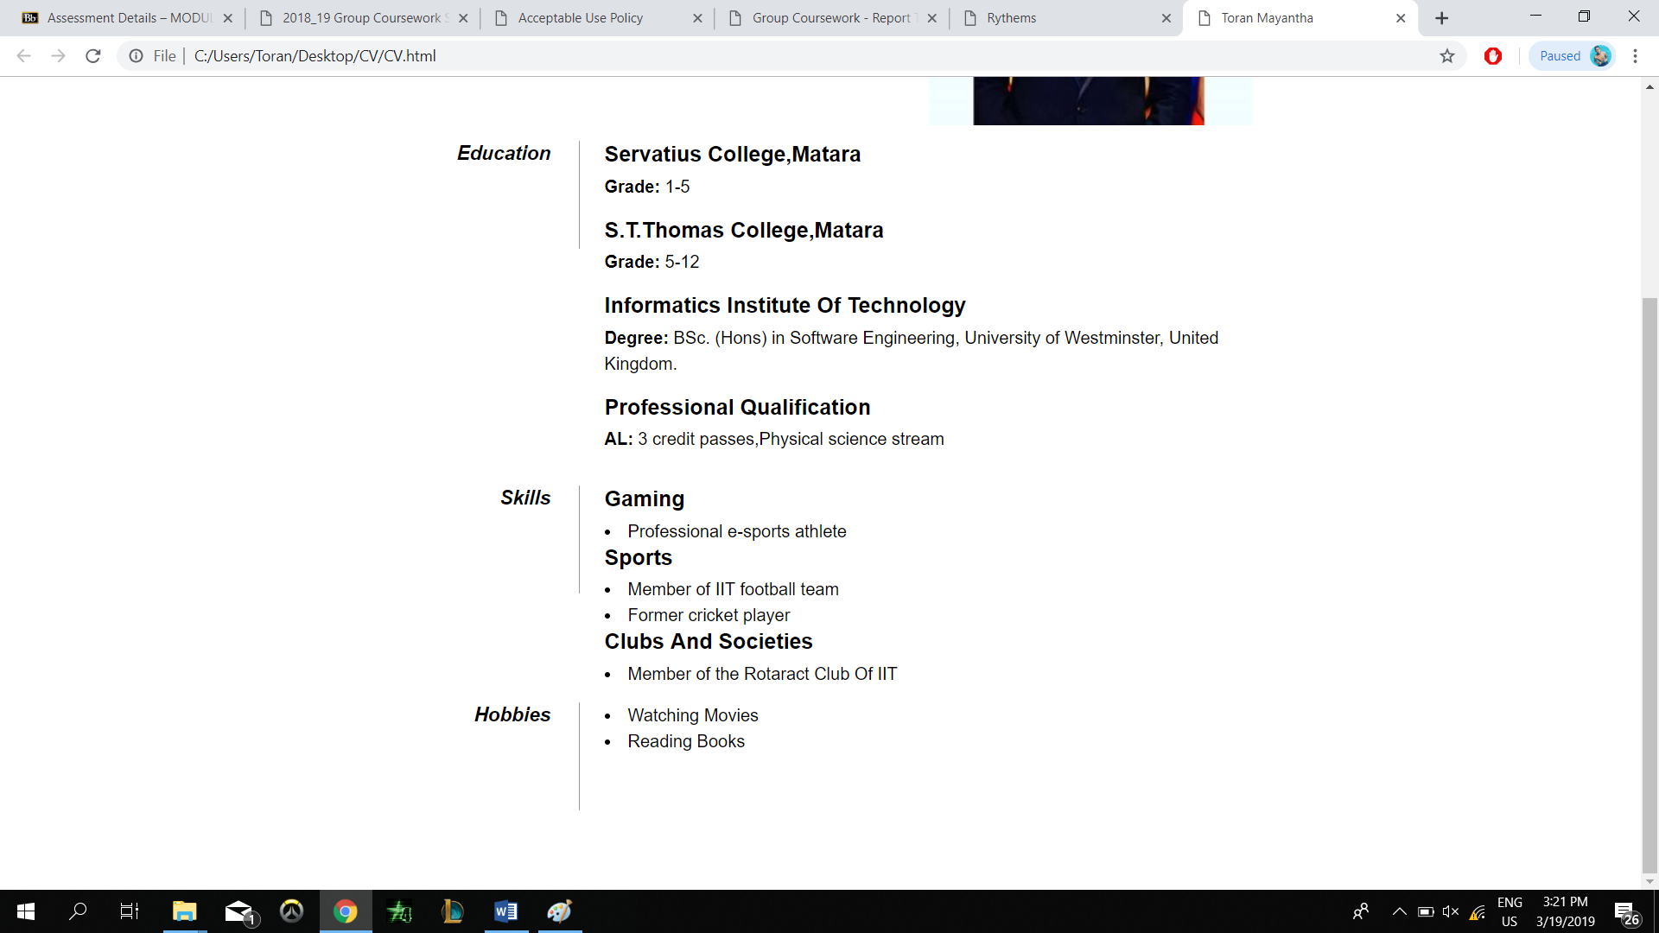

Appendix C : Individual Statement

|  |  |  |  |
| --- | --- | --- | --- |
| Student Name: Toran Mayantha |  | Student Id:2017373 |  |
| State what tasks you carried out in the project. | | | |
| Presentation Page  Store Page  CV | | | |
| State what you enjoyed and did not enjoy about teamwork. | | | |
| I enjoyed creating websites. Because it makes me happy and it feels good to scroll down the website that I made.  The thing that I didn’t enjoyed was when I was creating website and some tags were unclosed in HTML and I cant find where | | | |
| State what you learnt about teamwork. | | | |
| I learned to work with a team,without team this website is a dream.Team is a bond. Thats why the team is strong. | | | |
| State what skills you gained/learnt from undertaking the project. | | | |
| I gained a good knowledge about HTML,CSS and JavaScript  I learned to work as a team  Time Management  Stress Handling | | | |
| State any strengths about yourself that emerged whilst undertaking the project. | | | |
| Working hard until the project is finished.  Team management | | | |
| State any weaknesses about yourself that emerged whilst undertaking the  project. | | | |
| Sleeping too much when I have things to complete  Commanding others | | | |
| State how you would do things better if you were to undertake the project  again. | | | |
| Start the project early so that I can finish it early and lookout for mistakes and make the website way ore better. | | | |
| Additional general or project specific comments: | | | |
|  | | | |
| Student Signature: |  | Date:19/03/2019 |  |